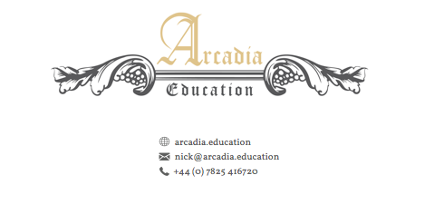
Spring Culture in Quarantine Online Course
Four Italian Renaissance Masterworks Decoded
Classics Under the Magnifying Glass
This mini course centres upon four arguably lesser-known Italian Renaissance masterpieces from the fifteenth and sixteenth centuries. With careful analysis and interpretation, I will endeavour to bring these paintings to life, in a time when we could all do with a little escapism. Hidden messages, concealed myths and religious symbology will form the basis for our four sessions; each devoted to one artwork.
A short course booklet will be provided, replete with recommended reading and suggested visits to view the artworks at close-quarters.

5th April
Session One – Patronage and Pageantry
Benozzo Gozzoli’s Procession of the Magi. View the painting here.

12th April
Session Two – A Study and a Saint
Antonello da Messina’s St Jerome. View the painting here.

19th April
Session Three – A Garden of Eternal Springtime
Sandro Botticelli’s La Primavera. View the painting here.

26th April
Session Four – A Nereid from the House of Farnese
Raffaello Sanzio’s (Raphael) Triumph of Galatea. View the painting here.
All sessions will take place via Zoom at 18:30 each week

To book your place on the course
Spring Italian Renaissance Course – Culture in Quarantine
To book your place please contact Katie at the following email address:
katehewer@hotmail.com
Further enquiries: 07720775087

Payment details:
Course cost is £40 per household for all 4 talks.
Once committed, we will send you the zoom details to join the sessions.

If you make a payment, please use your surname as a reference
Mrs K.A. Nelson
Coventry Building Society
Sort Code: 40-63-01
Account No: 67324685

