For Our Lady of the Rocks, by Leonardo da Vinci
by Dante Gabriel Rossetti

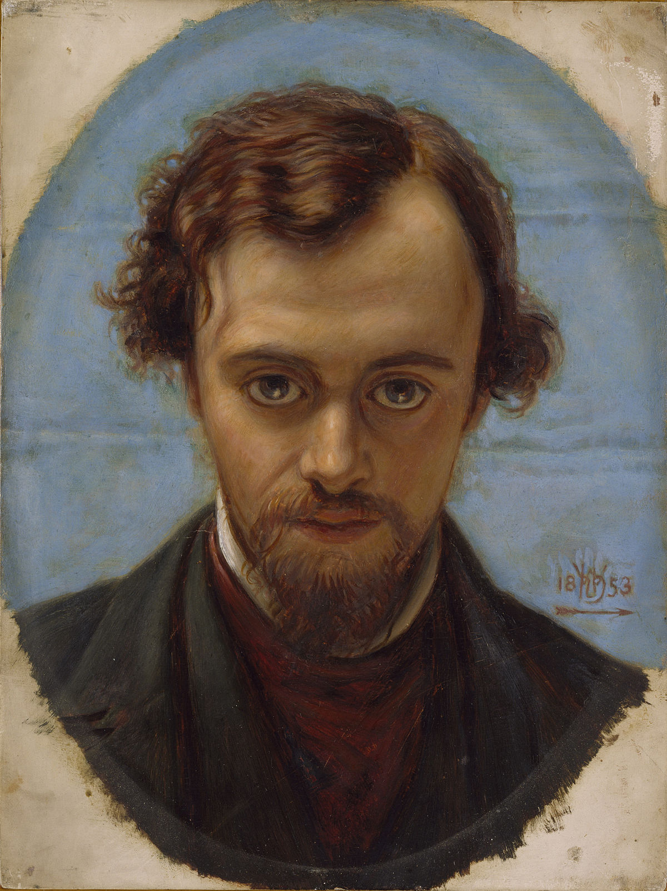

Mother, is this the darkness of the end,
The Shadow of Death? and is that outer sea
Infinite imminent Eternity?
And does the death-pang by man's seed sustained
In Time's each instant cause thy face to bend
Its silent prayer upon the Son, while He
Blesses the dead with His hand silently
To His long day which hours no more offend?
Mother of grace, the pass is difficult,
Keen as these rocks, and the bewildered souls
Throng it like echoes, blindly shuddering through.
Thy name, O Lord, each spirit's voice extols,
Whose peace abides in the dark avenue
Amid the bitterness of things occult.

